CMMC v2 Compliance for Log360
Strengthen cybersecurity and meet CMMC v2 compliance with Log360.
Region: USA | Type: Cybersecurity Framework, Industry Standard, Incident Management | Category: Compliance | Pricing: Free

Overview
The CMMC v2 compliance extension in Log360 helps organizations meet Cybersecurity Maturity Model Certification Version 2.0, the DoD framework mandating cybersecurity certification for all defense contractors handling FCI or CUI, aligned with NIST SP 800-171 by providing centralized log management, real-time threat detection, and continuous security monitoring. The platform supports CMMC v2 requirements for access control, audit logging, configuration management, multi-factor authentication, incident response, vulnerability scanning, system integrity, network protection, and continuous security monitoring.
For Access Control (AC), Log360 monitors logon events, privilege escalation, failed authentication, and account management changes to generate AC domain audit evidence. To address Audit and Accountability (AU), the platform provides centralized log collection, tamper-evident storage, automated analysis, and compliance dashboards fulfilling all nine AU domain practices. The extension also supports Configuration Management (CM) by providing capabilities that monitors configuration changes, software installation events, registry modifications, and application whitelisting to track CM domain compliance.

Key Features
- Identification and Authentication (IA): Log360 monitors authentication events, MFA enforcement, password audit activity, and failed logon attempts to provide complete IA domain audit evidence.
- Incident Response (IR): Log360 delivers real-time threat alerts, network attack detection, and forensic event timelines to support incident execution and DoD reporting obligations.
- Security Assessment and Continuous Monitoring (CA): Log360 provides real-time compliance dashboards and automated reporting mapped directly to CMMC Level 2 practices, enabling continuous oversight of the organization's security posture and audit readiness.
- System and Information Integrity (SI): Log360 ingests anti-malware events, threat detection reports, and IoC alerts to fulfil all seven SI domain practices across CUI systems.
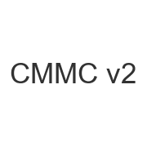
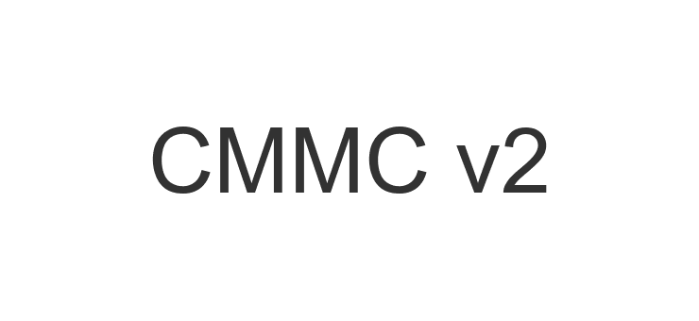
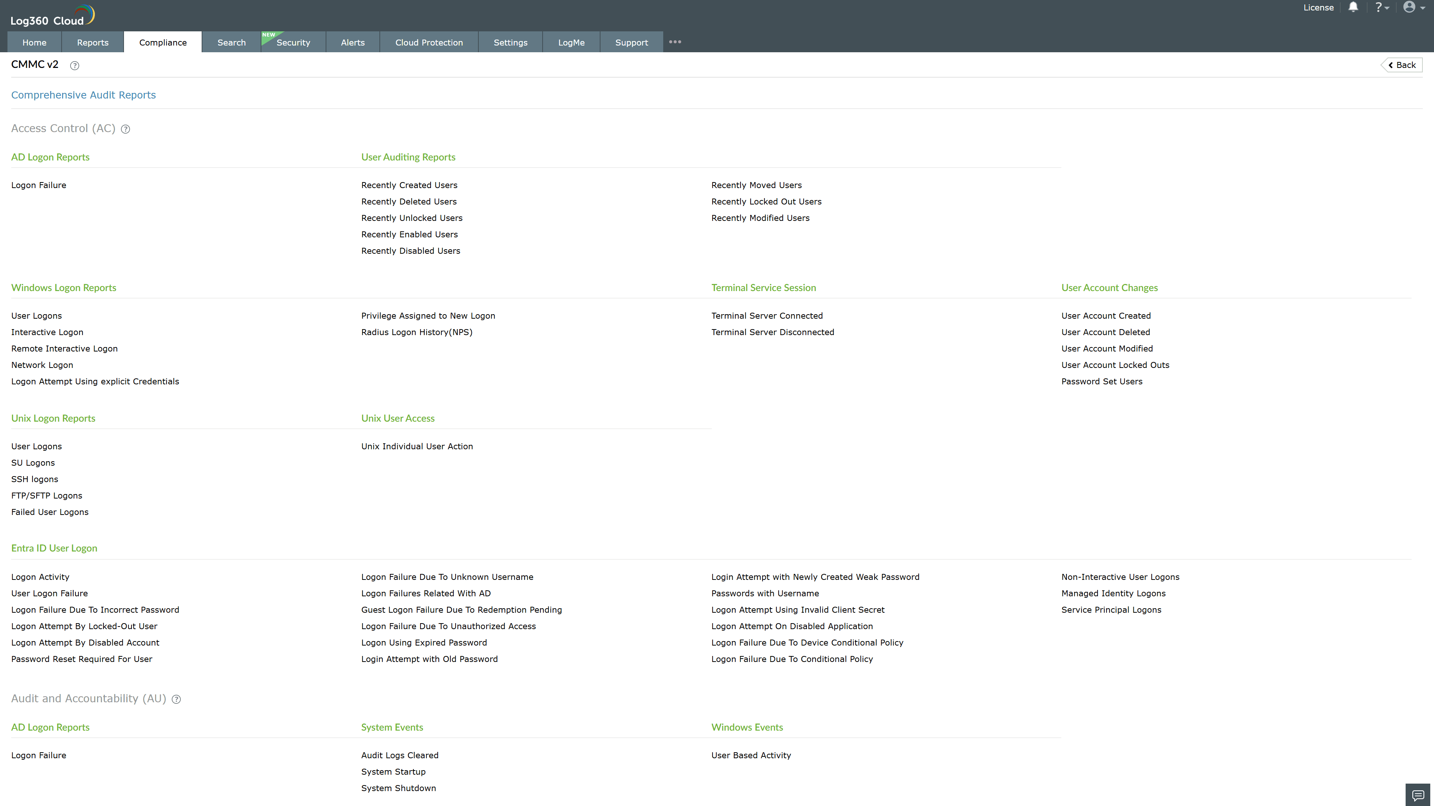
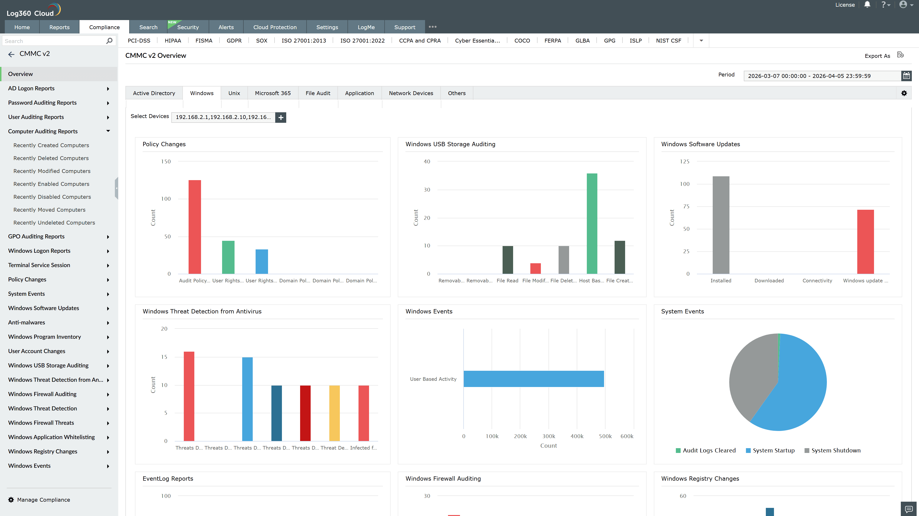
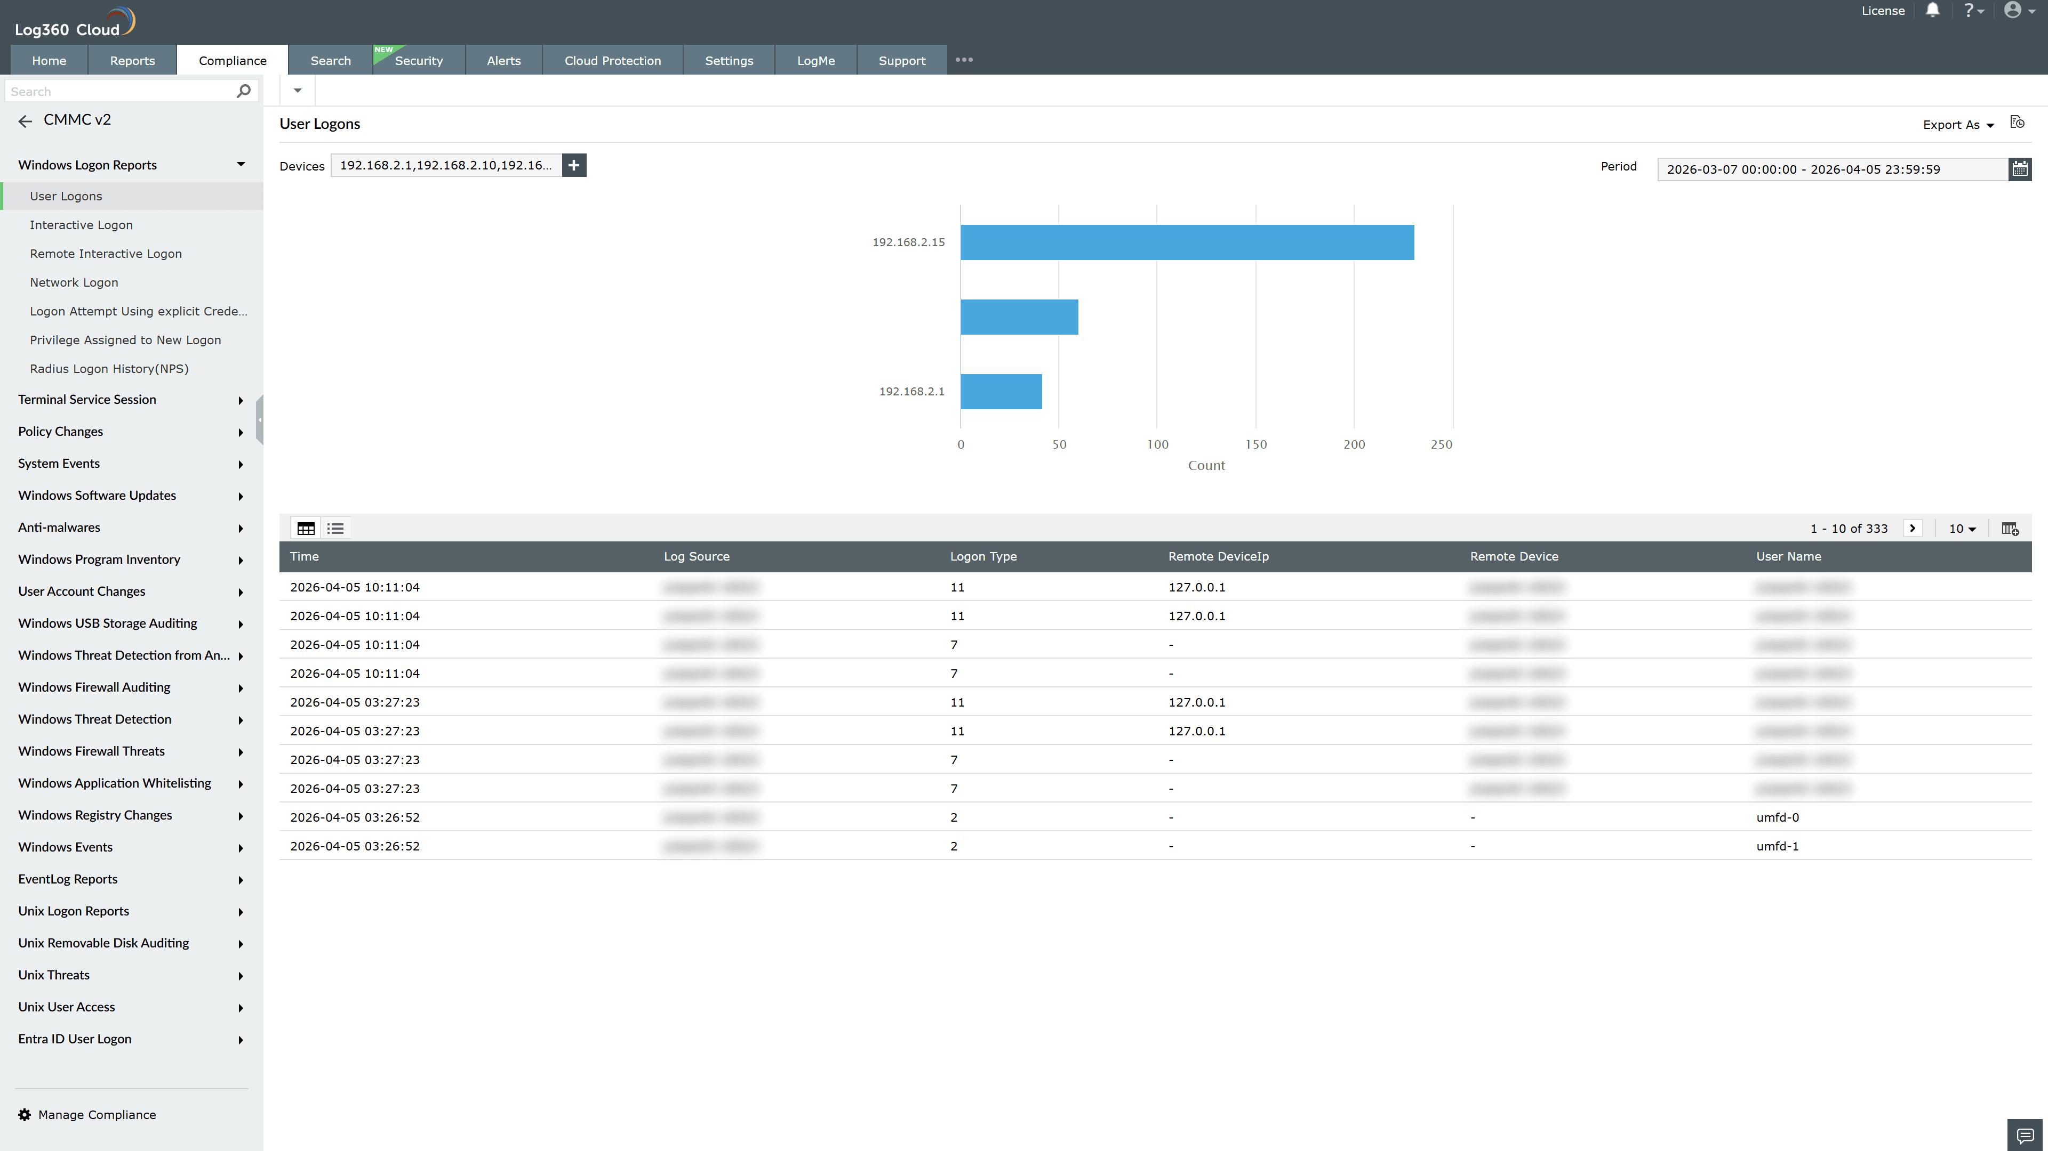
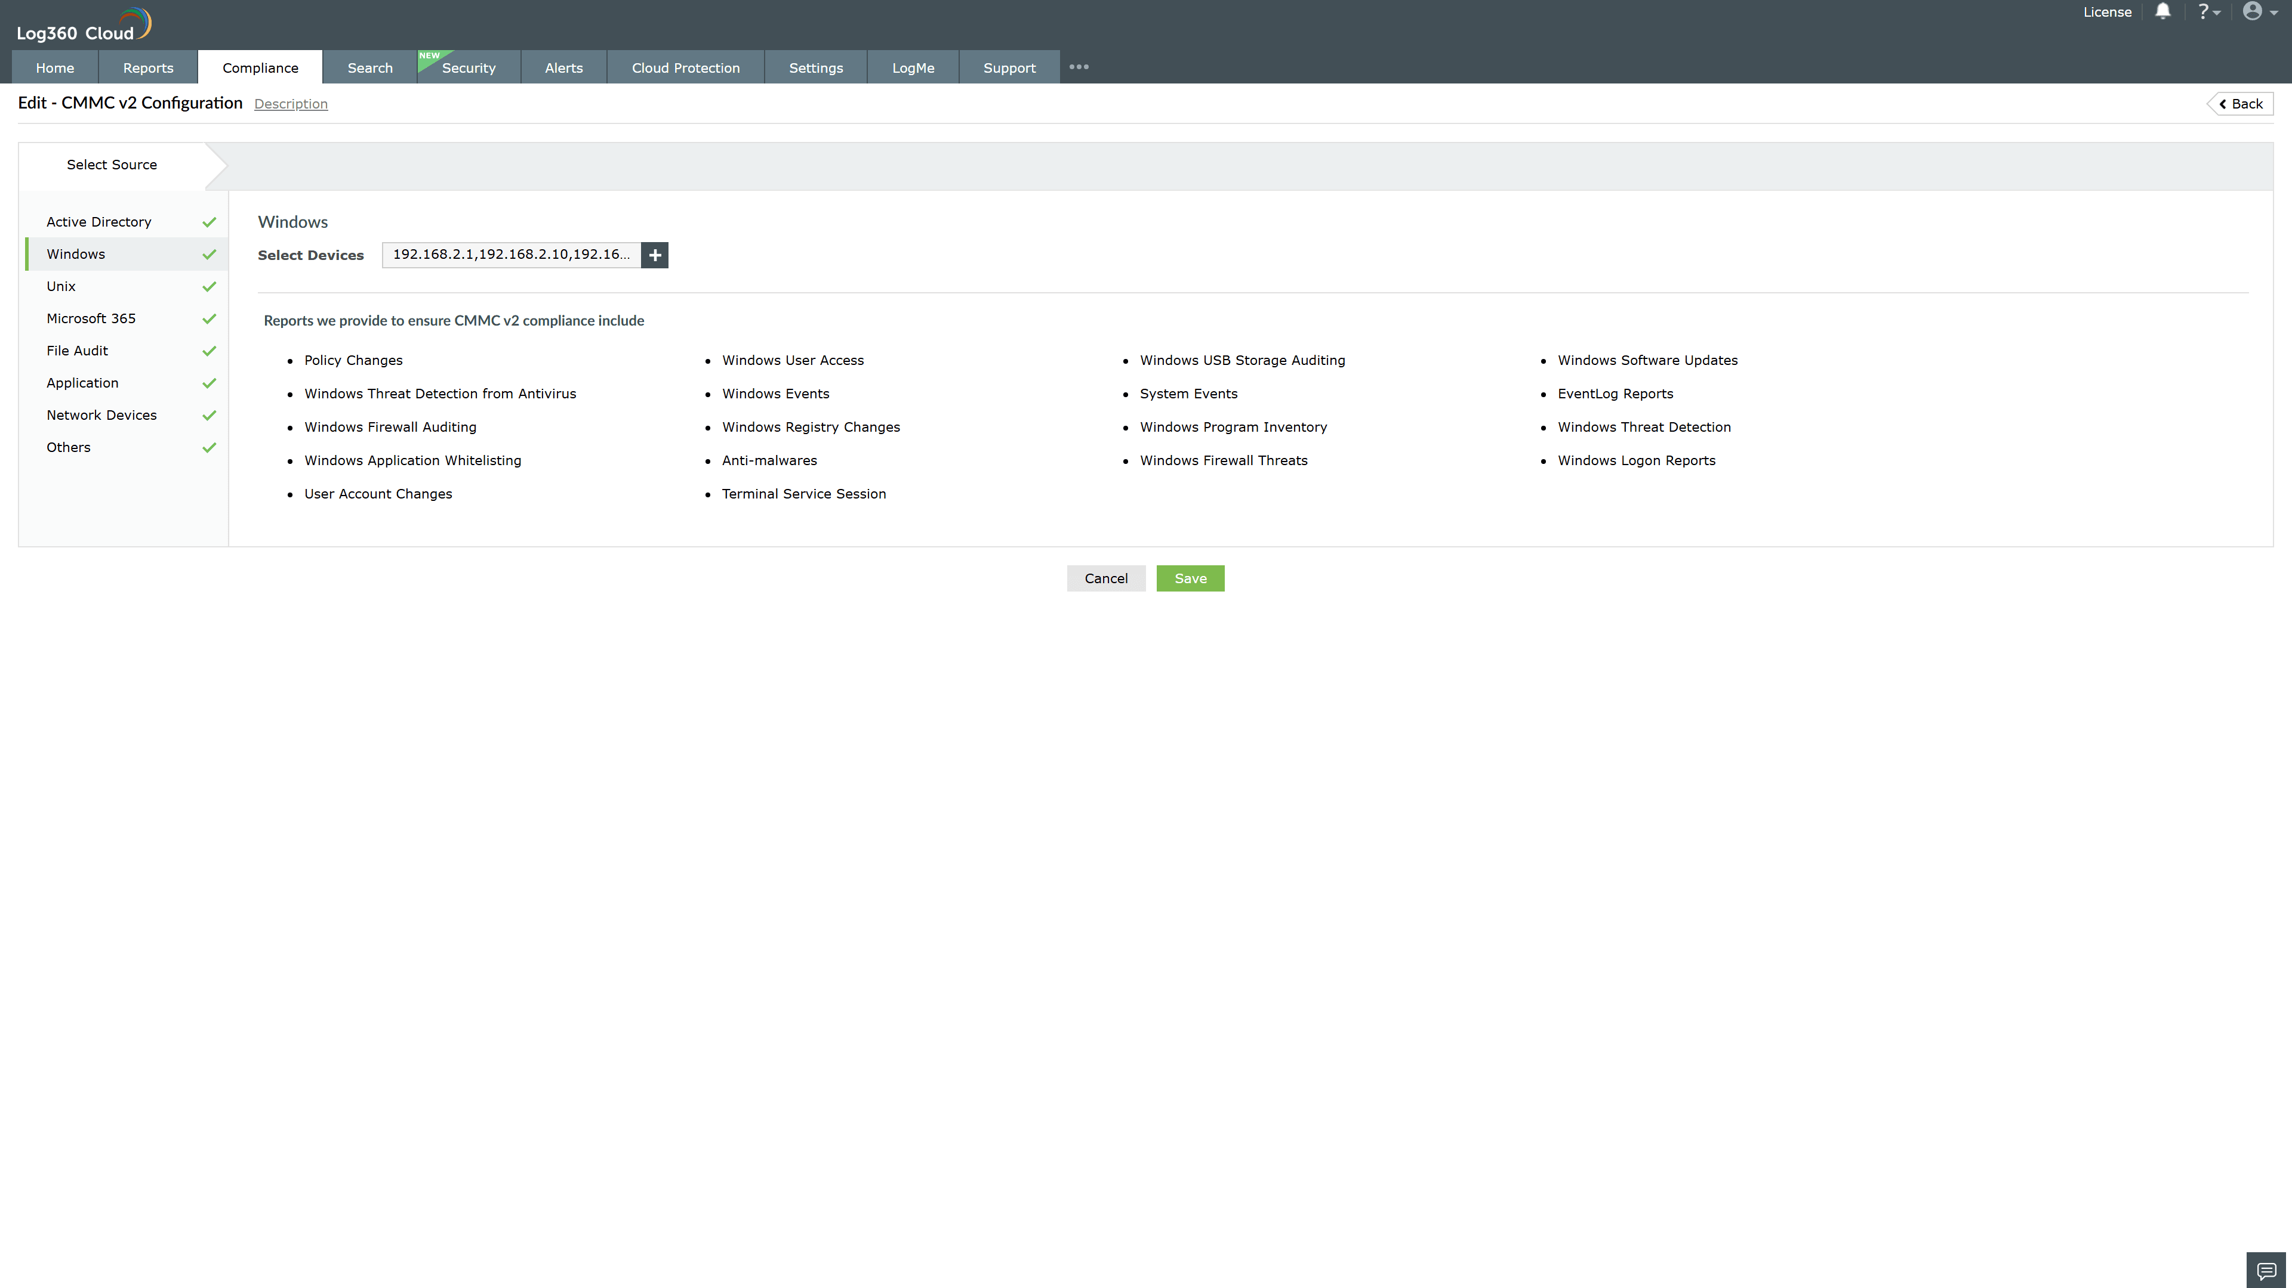
Valid Submission : Yes
Supported Editions : Free, Basic, Standard, Professional, MSSP
Help Document : https://www.manageengine.com/log-management/help/integrations/compliance-extensions.html
Help Video : Not provided
Tags : Log360, Compliance, Privacy monitoring, Data privacy, Regulatory compliance
Supported DCs : US, IN, JP, CA, AU, UK and EU
Privacy Policy:
Terms of Service:
Release Notes:
Predefined reports for the CMMC v2.

